COS30020 Lab 5: Files and Directories

References:

* Chapter 4 of your eText PHP Programming with MySQL.
* PHP File Processing / File Streams: <http://www.php.net/manual/en/refs.fileprocess.file.php>

**Aim:**

* To be able to use various file functions to create a Web page that allows visitors to your site to add their names to a ‘guest book’ that is saved as a text file.

## Getting Started:

Create a new folder ‘**lab05**’ under the unit folder on the mercury server

~/*cos30020/www/htdocs* folder on mercury. Save today’s work in this lab05 folder.

All Web pages should be validated.

You could also create and link an external stylesheet, to the pages, and this should be valid CSS3.

# Task 1: Understanding file functions (9 points)

### Step 1:

Create a file **shoppingsave.php** that will receive the input data from **shoppingform.php** from Step 2 via POST method, saves the item and quantity into a text file called **“shop.txt”** in the **“data”** directory, and then output all items in the text file. The item and quantity is to be delimited by comma when saved into the text file. For this exercise, no input validation aside from **isset()** is performed.

<!DOCTYPE html>

<html lang="en">

<head>

<meta charset="utf-8" />

<meta name="description" content="Web application development" />

<meta name="keywords" content="PHP" />

<meta name="author" content="Your Name" />

<title>TITLE</title>

</head>

<body>

<h1>Web Programming - Lab 5</h1>

<?php // read the comments for hints on how to answer each item

if ( **(1)** ) { // check if both form data exists

$item = $_POST[" **(2)** "]; // obtain the form item data

$qty = $_POST[" **(3)** "]; // obtain the form quantity data

$filename = "../../data/shop.txt"; // assumes php file is inside lab05

$handle = fopen($filename, "**(4)**"); // open the file in append mode

$data = **(5)** ; // concatenate item and qty delimited by comma

**(6)** ($handle, $data); // write string to text file

**(7)** ; // close the text file echo "<p>Shopping List</p> "; // generate shopping list

$handle = fopen($filename, "**(8)**"); // open the file in read mode while (! _**(9)_** ($handle)) { // loop while not end of file

$data = **(10)** ($handle); // read a line from the text file

echo "<p>", $data, "</p>"; // generate HTML output of the data

}

**(11)** ; // close the text file

} else { // no input

echo "<p>Please enter item and quantity in the input form.</p>";

}

?>

</body>

</html>

### Step 2:

Create a file **shoppingform.php** that contains a form with a two text boxes that allows a user to enter the item name to be purchases and a number representing the quantity, and submit it to **shoppingsave.php**.

<!DOCTYPE html>

<html lang="en">

<head>

<meta charset="utf-8" />

<meta name="description" content="Web application development" />

<meta name="keywords" content="PHP" />

<meta name="author" content="Your Name" />

<title>TITLE</title>

</head>

<body>

<h1>Web Programming Form - Lab 5</h1>

<form action =

#### (12)

method =

**(13)** >

#### (14-15)

</form>

</body>

</html>

# Task 2: Creating a Guest Book (6 points)

### Step 1:

Create a file **guestbookform.php** as shown below, that enables visitors to enter their names. Form action is to **guestbooksave.php** with method **post**.

The “Show Guest Book” link is to **guestbookshow.php**.

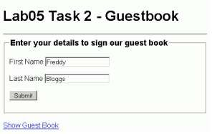

**Important - only do this if the ‘data’ directory does not exist.** *e.g. if using XAMPP locally*

* Before writing the script **guestbooksave.php** we need to check and set access permissions for our

**data** directory.

* We are going to create and access data files on mercury, in the ~/cos30020/www/data folder. Check if you have the **data** directory.
* If you are using XAMPP locally you will also need a **www/data** directory, so that when you test your work on mercury, everything will still works ☺
* Set permissions using chmod, or view and set “Properties” using your FTP software

chmod 02770 ~/cos30020/www/data

### Step 2:

Create a file guestbooksave.php with a script that checks the data entered, and then writes the Guest’s name to a guestbook.txt file.

First check if both guest names are provided, and if not, display an error message, and that suggests using the Browser’s ‘Go Back’ button to return to the form.

Open the file **guestbook.txt** ready to append the new data. If the file is writable, write the guest name as a single line string to the file, with appropriate ‘end of line’ escape characters, using fwrite.

**Hint:** Depending on your php configuration, you may need to first ‘escape’ any characters in the guests names with addslashes().

Check if the fwrite was successful or not, and echo messages, such as “Thank you for signing the Guest book” or “Cannot add your name to the Guest book”. Then close the file.

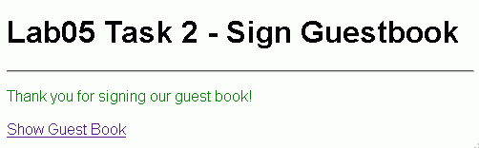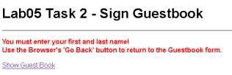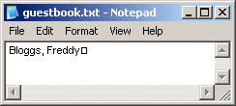

View the **guestbook.txt** file, say in Notepad.

**Note:**

The **guestbook.txt** file should be stored in a **lab05** directory under the **data** directory on mercury.

Add the following lines in the **guestbooksave.php** file to set the mask and to create the **'lab05'** directory under the **'data'** directory with access permissions:

umask(0007);

$dir = "../../data/lab05"; mkdir($dir, 02770);

Improve this script to only create the directory if it does not exist.

You will need to include the relative path whenever you write to, or read from, **guestbook.txt** file, that is:

"../../data/lab05/guestbook.txt"

*See:* https://feenix.swin.edu.au/help/?page=Mercury%20Web%20Server

### Step 3:

Create a file **guestbookshow.php** with a script to display a webpage that shows all the visitors that have signed the Guest Book.

If the file is readable, then use the readfile() function to extract the data from the file. Display the result within <pre></pre> elements, as this will recognise the line breaks in the text file.

**Hint:** Use stripslashes() to ‘unescape’ any characters in the guests names before displaying them.

**Note:** There are many alternate ways you could extract the data from the file, such as using the file_get_contents() function, using explode() to convert the file content into an array using the ‘end of line’ escape characters as the separator.

**Challenge:** Try other methods of reading and displaying the data.